Computer Programming Using Python 2.7 - Console 4 - Booleans, “while” Statement, and Nested Statements
GOALS: Use Booleans and nested statements (indented twice or more under a conditional that is under another conditional).
The teacher will explain Booleans and nested statements.
- Open IDLE, File, New Window
- File, Save As, Computer, H:, console4while.py
- Type the following:
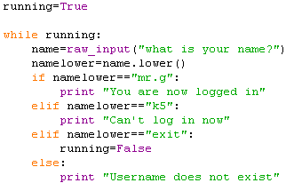

- Click Run, Run Module
BONUS: Without teacher’s help make something different happen if
logged in (Hint: use Booleans and the “if” statement)

